Uterine Polyps

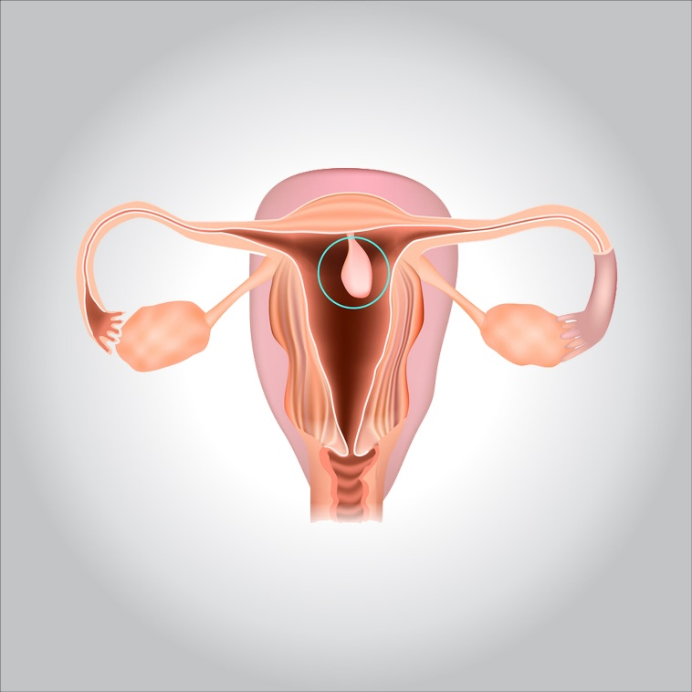

**Uterine polyps are growths attached to the inner wall of the uterus that extend into the uterine cavity. Overgrowth of cells in the lining of the uterus (endometrium) leads to the formation of uterine polyps, also known as endometrial polyps. These polyps are usually noncancerous (benign), although some can be cancerous or can eventually turn into cancer (precancerous polyps).**

**Uterine polyps range in size from a few millimeters — no larger than a sesame seed — to several centimeters — golf-ball-size or larger. They attach to the uterine wall by a large base or a thin stalk.**

**You can have one or many uterine polyps. They usually stay contained within your uterus, but occasionally, they slip down through the opening of the uterus (cervix) into your vagina. Uterine polyps most commonly occur in women who are going through or have completed menopause, although younger women can get them, too.**

**Symptoms**

**Signs and symptoms of uterine polyps include:**

* **Irregular menstrual bleeding — for example, having frequent, unpredictable periods of variable length and heaviness**
* **Bleeding between menstrual periods**
* **Excessively heavy menstrual periods**
* **Vaginal bleeding after menopause**
* **Infertility**

**Some women have only light bleeding or spotting; others are symptom-free.**

**When to see a doctor?**

**Seek medical care if you have:**

* **Vaginal bleeding after menopause**
* **Bleeding between menstrual periods**
* **Irregular menstrual bleeding**

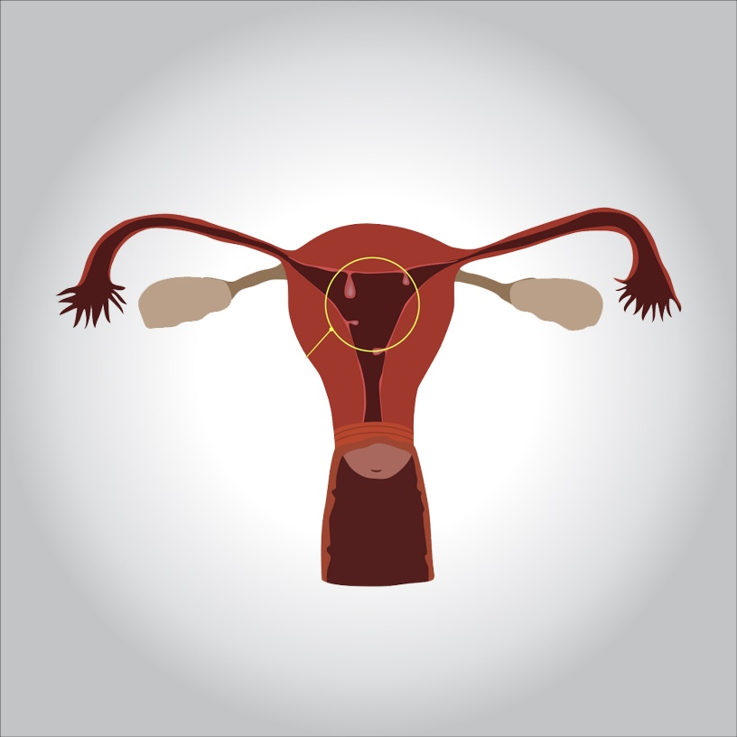

**Causes**

**Hormonal factors appear to play a role. Uterine polyps are estrogen-sensitive, meaning they grow in response to circulating estrogen.**

**Risk factors**

**Risk factors for developing uterine polyps include:**

* **Being perimenopausal or postmenopausal**
* **Having high blood pressure (hypertension)**
* **Being obese**
* **Taking tamoxifen, a drug therapy for breast cancer**

**Diagnosis**

**If your doctor suspects you have uterine polyps, he or she might perform one of the following:**

* **Transvaginal ultrasound. A slender, wand-like device placed in your vagina emits sound waves and creates an image of your uterus, including its interior. Your doctor may see a polyp that’s clearly present or may identify a uterine polyp as an area of thickened endometrial tissue.**

**A related procedure, known as hysterosonography (his-tur-o-suh-NOG-ruh-fee) — also called sonohysterography (son-oh-his-tur-OG-ruh-fee) — involves having salt water (saline) injected into your uterus through a small tube threaded through your vagina and cervix. The saline expands your uterine cavity, which gives the doctor a clearer view of the inside of your uterus during the ultrasound.**

* **Hysteroscopy. Your doctor inserts a thin, flexible, lighted telescope (hysteroscope) through your vagina and cervix into your uterus. Hysteroscopy allows your doctor to examine the inside of your uterus.**
* **Endometrial biopsy. Your doctor might use a suction catheter inside the uterus to collect a specimen for lab testing. Uterine polyps may be confirmed by an endometrial biopsy, but the biopsy could also miss the polyp.**

**Most uterine polyps are noncancerous (benign). However, some precancerous changes of the uterus (endometrial hyperplasia) or uterine cancers (endometrial carcinomas) appear as uterine polyps. Your doctor will likely recommend removal of the polyp and will send a tissue sample for lab analysis to be certain you don’t have uterine cancer.**

**Complications**

**Uterine polyps might be associated with infertility. If you have uterine polyps and you’re unable to have children, removal of the polyps might allow you to become pregnant, but the data are inconclusive.**

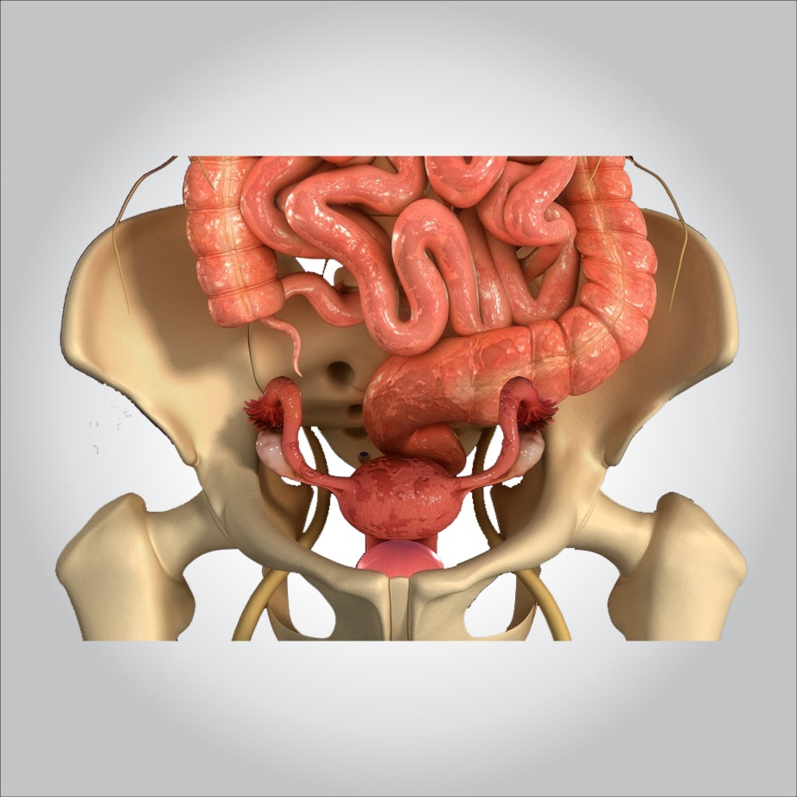

**Treatment**

**For uterine polyps, your doctor might recommend:**

* **Watchful waiting. Small polyps without symptoms might resolve on their own. Treatment of small polyps is unnecessary unless you’re at risk of uterine cancer.**
* **Medication. Certain hormonal medications, including progestins and gonadotropin-releasing hormone agonists, may lessen symptoms of the polyp. But taking such medications is usually a short-term solution at best — symptoms typically recur once you stop taking the medicine.**
* **Surgical removal. During hysteroscopy, instruments inserted through the hysteroscope — the device your doctor uses to see inside your uterus — make it possible to remove polyps. The removed polyp will likely be sent to a lab for microscopic examination.**

**If a uterine polyp contains cancerous cells, your doctor will talk with you about the next steps in evaluation and treatment.**

**Rarely, uterine polyps can recur. If they do, you might need more treatment.**